DIS-Costa Rica-Guanacasta-Nicoya-Axe Deity-Jadeite-

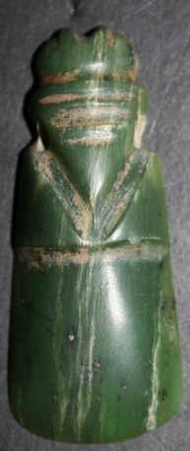 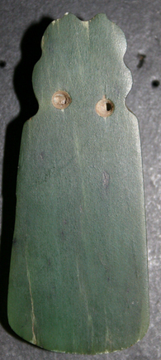

Costa Rica, Nicoya Culture, Axe Deity of Jadeite

**Formal Label:**

**Accession Number:**  [F1545.3.P6](http://luna.wellesley.edu/search%7ES1?/mF1545.3.P6+C67+1988/mf++1545.3+p6+c67+1988/-3,-1,,B/browse)

**Date or Time Horizon:** 200 BCE-200 CE

**Geographical Area:** Motagua river valley in Guatemala

**Cultural Affiliation:** Nicoya

**Medium:** Jadeite

**Dimensions:**

**Weight:**

**Provenance:**

**Condition:**

**Discussion:** The term jade should be properly applied to only two minerals: nephrite and jadeite. Nephrite is a calcium and magnesium silicate, and can be found in a variety of colors, from translucent white, to yellow, and all shades of green. Nephrite doesn’t occur naturally in Mesoamerica. Jadeite, a sodium and aluminum silicate, is a hard and highly translucent stone whose color ranges from blue-green, to apple green. The only known prehistoric source of jadeite in Mesoamerica is the Motagua River valley in Guatemala. If prehistoric peoples of Mesoamerica used this source alone rather than unknown or depleted multiple sources of the precious stone (such as Rio Balsas basin in Mexico, and the Santa Elena region in Costa Rica), then inter-regional trade must have been active in the exchange of this valuable élite stone.

It is also necessary to distinguish between “geological jade” and “social” jade: the former term indicates actual jadeite, whereas the latter term indicates other, similar greenstones, such as quartz and serpentine which were not as rare as jadeite but were similar in color and therefore fulfilled the same social function.

Jade’s cultural significance is its green color, the color of life, which was associated with water, and vegetation (especially maturing maize). Olmec, Maya, Aztec and Costa Rican elites particularly appreciated jade carvings and artifacts and commissioned elegant pieces from skillful artisans. Jade was traded and exchanged among elite members as a luxury item all over the pre-Hispanic American world. It was replaced by gold very late in time in Mesoamerica, and around 500 AD in Costa Rica and Lower Central America. In these locations, frequent contacts with South America made gold more easily available.

Jade artifacts are often found elite burial contexts, as personal adornments or accompanying objects. Sometimes a jade bead was placed within the mouth of the deceased. Jade objects are also found in dedicatory offerings for the construction or ritual termination of public buildings, as well as in more private residential contexts.

### Examples of Jade Artifacts

In the Formative period, the Olmec of the Gulf Coast were among the first Mesoamerican people to shape jade into votive celts, axes, and bloodletting tools around 1200-1000 BC. The Maya achieved master levels of jade carving. Maya artisans used drawing cords, harder minerals and water as abrasive tools to work the stone. Holes were made in jade objects with bone and wood drills, and finer incisions were often added at the end. Jade objects varied in size and shapes and included necklaces, pendants, pectorals, ear ornaments, beads, mosaic masks, vessels, rings, and statues.

Among the most famous jade artifacts from the Maya region we can include funeral masks and vessels from Tikal, and Pakal’s funeral mask and jewels from the Temple of the Inscriptions at Palenque. Other burial offerings and dedication caches have been found at major Maya sites, such as Copan, Cerros, and Calakmul.

During the Postclassic period, the use of jade dropped dramatically in the Maya area. Jade carvings are rare, with the notable exception of the pieces dredged out of the Sacred Cenote at Chichén Itzá. Among Aztec nobility, jade jewelry was the most valuable luxury: partly because of its rarity, since it had to be imported from the tropical lowlands, and partly because of its symbolism linked to water, fertility and preciousness. For this reason, jade was one of the most valuable tribute item collected by the Aztec Triple Alliance.

### Jade in Southeastern Mesoamerica and Lower Central America

Southeastern Mesoamerica and Lower Central America were other important regions of the distribution of jade artifacts. In the Costa Rican regions of Guanacaste-Nicoya jade artifacts were mainly widespread between AD 200 and 600. Although no local source of jadeite has been identified so far, Costa Rica and Honduras developed their own jade-working tradition. In Honduras, non-Maya areas show a preference of using jade in building dedication offerings more than burials. In Costa Rica, by contrast, the majority of jade artifacts have been recovered from burials. The use of jade in Costa Rica seems to come to an end around A.D. 500-600, when there was a shift towards gold as the luxury raw material; that technology originated in Colombia and Panama.

### Jade Study Problems

Unfortunately, jade artifacts are hard to date, even if found in a relatively clear chronological context, since this particularly precious and hard-to-find material was often passed down from one generation to another as heirlooms. Finally, because of their value, jade objects are often looted from archaeological sites and sold to private collectors. For this reason, a huge number of published items are from unknown provenience, and are missing an important piece of information.

**References:**

Lange, Frederick W., 1993, Precolumbian Jade: New Geological and Cultural Interpretations. University of Utah Press.

Seitz, R., G.E. Harlow, V.B. Sisson, and K.A. Taube, 2001, Olmec Blue and Formative Jade Sources: New Discoveries in Guatemala, Antiquity, 75: 687-688